SIMATS ENGINEERING (SAVEETHA SCHOOL OF ENGINEERING)
Department of Computer Science and Engineering
CO4 ASSESSMENT TOOL 1 – Test Case Design Assignment

Course Code: | CSA10 | Course Title: | Software Engineering
CO Assessed: | CO4 | Assessment: | Assessment Tool 1 – Test Case Design Assignment
Weightage: | 20% | Total Marks: | 25
CO4 Statement: | Implement robust testing, quality assurance, and DevOps practices, emphasizing security, reliability, and ethics
Student Name: | Surya Krishna Teja Yandra | Reg. No.: | 192425065
Date: | 18-08-2026 | Duration: | 60 minutes

Code of Conduct
I Surya Krishna Teja Yandra/192425065 (Name / Reg No) certify that this submission is my original work and that I have adhered to the guidelines specified for this assessment. I understand that any violation of academic integrity rules will result in disciplinary action.
Signature of the Student: _________________________
Annexure A – Test Case Design Assignment
Instructions to Students:
Each student is assigned an individual problem statement. Based on the assigned problem statement, design and document comprehensive test cases to verify the correctness, functionality, reliability, and usability of the proposed system.
Your test case design should include:
- Identify the functional and non-functional requirements to be tested.
- Identify the test scenarios for the assigned problem statement.
- Prepare detailed test cases covering normal, boundary, invalid, and exceptional conditions.
- Include Test Case ID, Test Scenario, Test Steps, Test Data, Expected Result, Actual Result, and Pass/Fail Status.
- Apply appropriate test design techniques such as Equivalence Partitioning, Boundary Value Analysis, Decision Table, or State Transition Testing wherever applicable.
- Ensure that the test cases provide adequate requirement and functional coverage for the assigned system.
Deliverable: Submit a Test Case Design document containing the identified scenarios, test cases, test data, expected results, and test coverage based on the individual problem statement.

Rubrics for Calculation
Evaluation Criteria | Excellent (4 Marks) | Good (3 Marks) | Satisfactory (2 Marks) | Needs Improvement (1 Mark)
Requirement & Test Scenario Identification(15%) | Clearly identifies all relevant functional/non-functional requirements and comprehensive test scenarios | Identifies most requirements and scenarios | Identifies basic requirements and scenarios | Requirements/scenarios are incomplete or unclear
Test Case Design & Completeness(25%) | Comprehensive test cases covering normal, boundary, invalid, and exceptional conditions | Covers most important conditions with minor gaps | Covers basic conditions but misses several important cases | Test cases are very limited or incomplete
Test Data & Expected Results(20%) | Appropriate test data with precise, measurable expected results for every test case | Mostly appropriate test data and expected results | Some test data/results are unclear or incomplete | Test data and expected results are largely missing/incorrect
Application of Test Design Techniques(15%) | Correctly applies multiple techniques such as Equivalence Partitioning, Boundary Value Analysis, Decision Table, and State Transition | Correctly applies at least two relevant techniques | Applies one technique with limited justification | Techniques are not applied or incorrectly applied
Traceability & Test Coverage(15%) | Excellent mapping between requirements, scenarios, and test cases with strong coverage | Good traceability and coverage with minor gaps | Partial traceability and moderate coverage | Poor/no traceability and inadequate coverage
Documentation & Presentation(10%) | Well-structured, clear, professional, consistent, and easy to understand | Well-organized with minor presentation issues | Adequately organized but has some clarity/formatting issues | Poorly organized, unclear, or incomplete documentation

Criteria | Mark
Requirement & Test Scenario Identification (15%) | /5
Test Case Design & Completeness (25%) | /4
Test Data & Expected Results (20%) | /4
Application of Test Design Techniques (15%) | /4
Traceability & Test Coverage (15%) | /4
Documentation & Presentation (10%) | /4
TOTAL | /25

AI-Driven Smart Disaster Relief Resource Allocation and Volunteer Coordination Platform

1. Requirement & Test Scenario Identification — 15%

Functional Requirements
ID | Functional Requirement | Test Scenario
FR01 | Register/login users | Valid and invalid login
FR02 | Register disaster details | Add disaster type, location, severity
FR03 | Manage relief resources | Add, update, delete, and view resources
FR04 | Monitor resource availability | Check available/low/out-of-stock resources
FR05 | Register volunteers | Add volunteer details and location
FR06 | Assign volunteers | Assign volunteers based on location and skills
FR07 | AI-based prioritization | Prioritize affected areas based on severity and population
FR08 | Resource allocation | Allocate food, medicine, shelter, etc.
FR09 | Route optimization | Generate shortest/fastest relief route
FR10 | Real-time dashboard | Display disasters, resources and volunteers
FR11 | Notifications | Send emergency alerts and assignment notifications
FR12 | Inter-agency coordination | Share relief information between authorized agencies
Non-Functional Requirements
- Performance: Dashboard and allocation results should load quickly.
- Security: Only authorized users can access sensitive disaster information.
- Availability: System should remain operational during high-demand situations.
- Scalability: System should support increasing disasters, volunteers, and resources.
- Usability: Emergency operators should easily understand the dashboard.
- Reliability: Resource quantities and volunteer assignments must remain accurate.
- Data integrity: Duplicate or invalid resource entries should be prevented.

2. Test Case Design & Completeness — 25%

TC ID | Requirement | Test Case | Type | Expected Result
TC01 | FR01 | Login with valid username/password | Normal | User successfully logs in
TC02 | FR01 | Login with incorrect password | Invalid | Error message displayed
TC03 | FR02 | Add disaster with all valid details | Normal | Disaster successfully registered
TC04 | FR02 | Submit disaster without location | Invalid | System rejects submission
TC05 | FR02 | Enter severity = minimum value | Boundary | Lowest valid severity accepted
TC06 | FR02 | Enter severity above maximum | Boundary | Invalid severity rejected
TC07 | FR03 | Add 500 food packets | Normal | Quantity stored as 500
TC08 | FR03 | Enter resource quantity = 0 | Boundary | System handles zero stock correctly
TC09 | FR03 | Enter negative quantity | Invalid | Negative value rejected
TC10 | FR04 | Reduce resource stock after allocation | Normal | Available quantity decreases correctly
TC11 | FR05 | Register volunteer with valid skills/location | Normal | Volunteer registered
TC12 | FR05 | Register volunteer with missing phone number | Invalid | Registration rejected
TC13 | FR06 | Assign nearby medical volunteer | Normal | Suitable volunteer assigned
TC14 | FR06 | No qualified volunteer available | Exceptional | System reports unavailable volunteer
TC15 | FR07 | Area has high severity and large population | AI decision | Area receives high priority
TC16 | FR07 | Two areas have equal priority | Decision | System applies defined tie-breaking rule
TC17 | FR08 | Allocate sufficient resources | Normal | Allocation completed successfully
TC18 | FR08 | Requested quantity exceeds stock | Exceptional | Partial allocation/shortage warning displayed
TC19 | FR09 | Calculate route between relief center and affected area | Normal | Valid optimized route displayed
TC20 | FR09 | Road is unavailable | Exceptional | Alternative route generated
TC21 | FR10 | Open emergency dashboard | Normal | Current data displayed
TC22 | FR10 | Multiple disasters occur simultaneously | Stress | Dashboard displays all active disasters
TC23 | FR11 | Send emergency notification | Normal | Notification delivered
TC24 | FR12 | Unauthorized agency attempts access | Security | Access denied
TC25 | NFR Performance | 100 users access dashboard simultaneously | Performance | System remains responsive
TC26 | NFR Security | Attempt unauthorized resource modification | Security | Modification blocked
TC27 | NFR Reliability | Server temporarily loses connection | Exceptional | System handles failure without data corruption
TC28 | NFR Scalability | Add large number of volunteers/resources | Stress | System continues functioning correctly

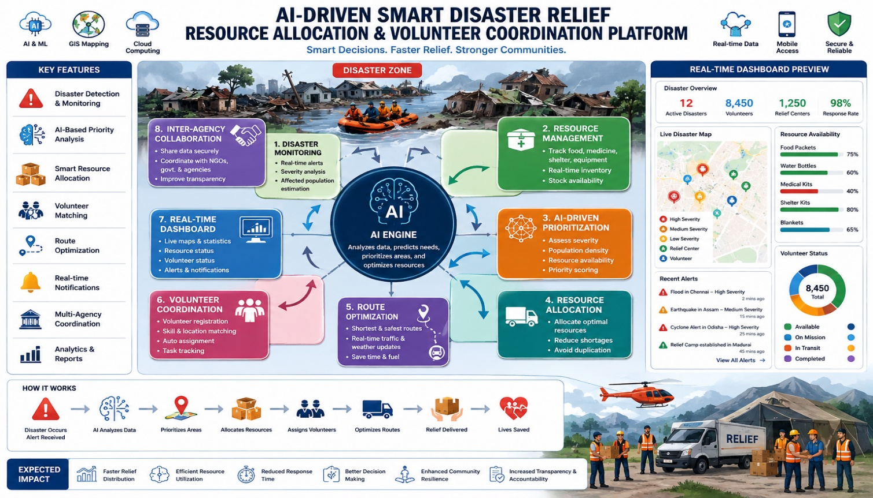
3. Test Data & Expected Results — 20%
Sample Disaster Data
Field | Test Data
Disaster ID | D001
Disaster Type | Flood
Location | Chennai
Severity | 5/5
Affected Population | 25,000
Priority | Critical
Sample Resource Data
Resource | Available | Required | Expected
Food packets | 10,000 | 8,000 | Full allocation
Water bottles | 5,000 | 7,000 | 5,000 allocated + shortage warning
Medical kits | 1,000 | 500 | 500 remaining
Blankets | 2,000 | 2,000 | Stock becomes 0
Sample Volunteer Data
Volunteer | Skill | Location | Expected Assignment
V001 | Medical | Chennai | Medical emergency
V002 | Logistics | Chennai | Resource distribution
V003 | Transport | Kanchipuram | Transportation
V004 | Food Distribution | Chennai | Food distribution
Example measurable result:
If 8,000 food packets are requested and 10,000 are available:
Allocated = 8,000
Remaining = 2,000
If 7,000 water bottles are requested and only 5,000 are available:
Allocated = 5,000
Shortage = 2,000

4. Application of Test Design Techniques — 15%
A. Equivalence Partitioning
For resource quantity:
- Valid: 1–10,000
- Invalid: <1
- Invalid: >10,000
Example:
Input | Partition | Expected
500 | Valid | Accepted
0 | Invalid | Rejected/handled as zero stock
-10 | Invalid | Rejected
15,000 | Invalid | Rejected
B. Boundary Value Analysis
For disaster severity (1–5):
Test values:
0, 1, 2, 4, 5, 6
Expected:
- 0 → Invalid
- 1 → Valid
- 2 → Valid
- 4 → Valid
- 5 → Valid
- 6 → Invalid
C. Decision Table
Resource Allocation
Severity | Population | Resource Available | Decision
High | High | Yes | Immediate full allocation
High | High | No | Partial allocation + shortage alert
High | Low | Yes | Priority allocation
Low | High | Yes | Normal allocation
Low | Low | No | Queue/request additional resources
D. State Transition Testing
Volunteer states:
Registered → Available → Assigned → On Mission → Completed
Exceptional transition:
Available → Unavailable
The system should prevent an Unavailable volunteer from receiving a new assignment.

5. Traceability & Test Coverage — 15%
Requirement | Test Cases | Coverage
FR01 Login | TC01–TC02 | 100%
FR02 Disaster Registration | TC03–TC06 | 100%
FR03 Resource Management | TC07–TC09 | 100%
FR04 Resource Monitoring | TC10 | 100%
FR05 Volunteer Registration | TC11–TC12 | 100%
FR06 Volunteer Assignment | TC13–TC14 | 100%
FR07 AI Prioritization | TC15–TC16 | 100%
FR08 Resource Allocation | TC17–TC18 | 100%
FR09 Route Optimization | TC19–TC20 | 100%
FR10 Dashboard | TC21–TC22 | 100%
FR11 Notifications | TC23 | 100%
FR12 Inter-agency Coordination | TC24 | 100%
NFR Performance | TC25 | Covered
NFR Security | TC26 | Covered
NFR Reliability | TC27 | Covered
NFR Scalability | TC28 | Covered
Overall test coverage = 100% of identified major requirements.

6. Documentation & Presentation — 10%
The testing documentation should be organized in this order:
- Project Title
- Project Overview
- Functional Requirements
- Non-Functional Requirements
- Test Scenarios
- Test Cases
- Test Data
- Expected Results
- Test Design Techniques
- Requirement Traceability Matrix
- Test Coverage
- Defect/Exception Handling
- Test Summary

Final Testing Objective
The platform should be considered successful when it can correctly identify disaster priorities, allocate available resources, assign suitable volunteers, optimize relief routes, update information in real time, and handle invalid, boundary, exceptional, security, performance, and high-load conditions without data loss or incorrect allocation.
This structure directly addresses all six rubric criteria and is suitable for a 4-mark/Excellent-level testing submission.

